**Lab 3: Random Number Generation**

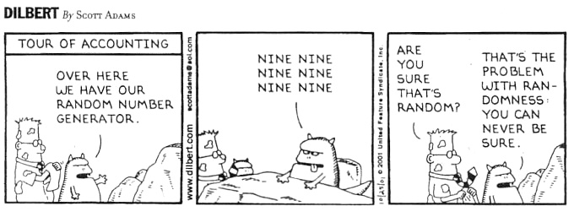

**Analyse the following problems in groups,**

1. Implement LCG in any programming language, such as C, Java, python or MATLab.
2. Choose different values for *a, b, c* and *m*.
3. Choose your own methodology to determine whether your choice is good or not.
4. Evaluate the random number generator (integer) provided by <https://www.random.org>
5. Any other random number generator or resource you like to share?

**Submission**:

Summarise all your implementation and analysis results in a two-page document (per group). Your report can cover the following details but not limited to:

1. Your group member, responsibility of each team member and contribution in percentage.
2. Your approach for implementation
3. Reasons why you choose those specific values for *a, b, c* and *m*
4. Reasons why some values are good some are bad.
5. How did you evaluate the Integer number random generator from <https://www.random.org>? Comparing to their generator, is yours better?
6. Any other generators you know that can give good randomness?

**Deadline**: 10th October 2019

**DO NOY copy and paste from online resources.**